TECH-80 CABLE

- PARTS:

QUANTITY: PART #: NOMENCLATURE: LENGTH:

1 PER MACHINE 19276- CABLE, MOTION CONTROL 19 INCHES

2 PER MACHINE 17464-8 CONNECTOR, SOCKET W/RELIEF N/A

4 PER MACHINE 18776- PLUG, KEYING N/A

- ASSEMBLY:

- CUT THE TWIN-ENDED PART OF THE CABLE SO THAT THERE IS ONLY 19 INCHES BETWEEN THE BLACK CONNECTOR AND THE CUT ENDS.

- WITH THE BLACK CONNECTOR FACING DOWN (THE RED STRIPED WIRE TOWARDS YOU), CUT ONE INCH OFF OF THE TOP CABLE END, ACCORDING TO DIAGRAM 1..

- ATTACH THE CONNECTORS TO THE CABLES, WITH THE RED STRIPED WIRES TOWARDS THE ARROWS ON THE CONNECTORS, ACCORDING TO DIAGRAM 1.

- 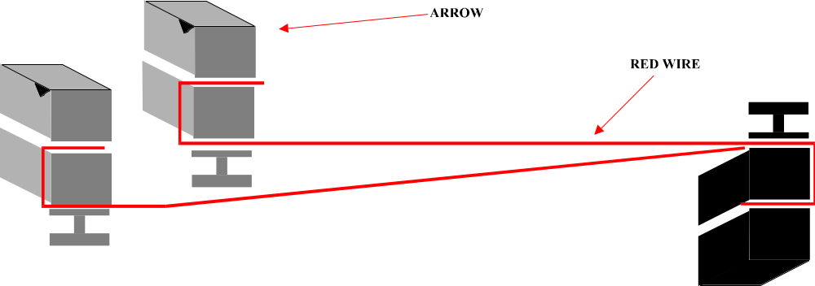INSERT THE KEYING PLUGS ACCORDING TO DIAGRAM 2.

DIAGRAM 1

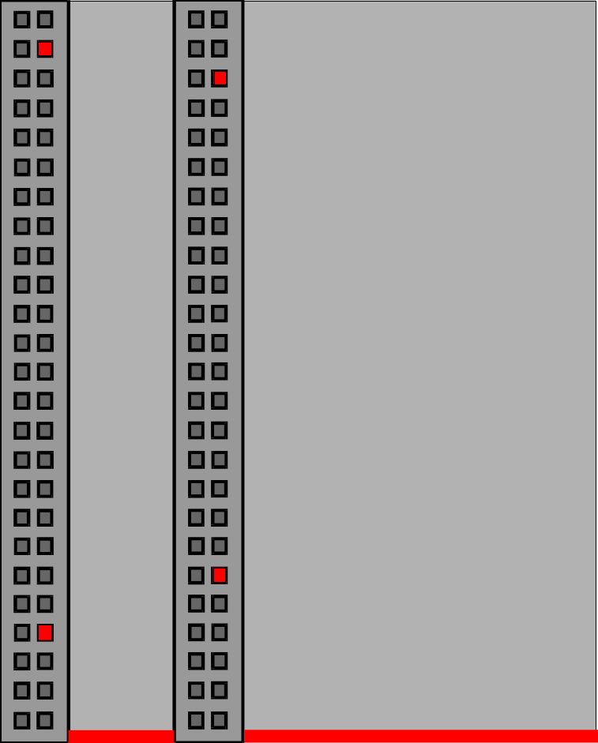

DIAGRAM 2

